Inheritance
Workshop #6
Flutter Developer Bootcamp

Purpose
This workshop demonstrates the class inheritance and how properties are inherited and accessed through subclass instances.

Problem
In the given workshop demonstrates the class inheritance and property access. It defines three classes: cs, cs1, and cs2.
- Class cs inherits from cs1 and introduces its own property cs_String.
- Class cs1 inherits from cs2 and adds its own property str.
- Class cs2 defines the property str1.
In the main function, an instance of cs is created (obj), demonstrating how properties from all three classes (cs_String, str, and str1) are accessed and printed. This example highlights Dart's support for hierarchical class structures and property inheritance, essential for organizing and reusing code effectively in object-oriented programming. You need to solve the error in the given code.

How to Solve
- Checkout the workshop from Git Repo:
git clone -b <user-branch> <repo-URL>
- Open the root folder inside VS Code
- Open the root folder in terminal
- Run the command dart run filename.dart
- Class Definitions:
- cs inherits from cs1 and introduces cs_String.
- cs1 inherits from cs2 and adds str.
- cs2 defines str1.
- Error Resolution:
- Ensure proper hierarchical inheritance (cs from cs1, cs1 from cs2).
- Correct property definitions in each class (cs_String, str, str1).
- Main Function Execution:
- Creates an instance obj of cs.
- Accesses properties cs_String, str, and str1 from obj.
- Go To File: <specific-file--method> à <method-name>, implement your logic.

You will Achieve
When you complete this workshop you will learn the following:

Achievements:

- Understanding Class Inheritance:
- Learn how classes (cs, cs1, cs2) can inherit properties and behaviors from parent classes, creating a hierarchical structure.
- Property Access:
- Explore how properties (cs_String, str, str1) defined in different levels of the class hierarchy can be accessed and utilized.
- Error Resolution:
- Address any potential issues related to class inheritance, ensuring proper definition and access of properties.

Components:

- Class Definitions:
- cs: Inherits from cs1 and introduces cs_String.
- cs1: Inherits from cs2 and adds str.
- cs2: Defines str1.
- Main Function:
- Creates an instance (obj) of cs.
- Accesses and prints cs_String, str, and str1 properties from obj.

Screenshots

Before implementation (without solving error)

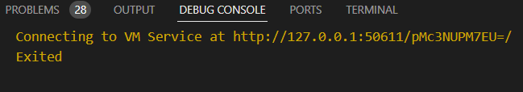

After implementation (solving error)

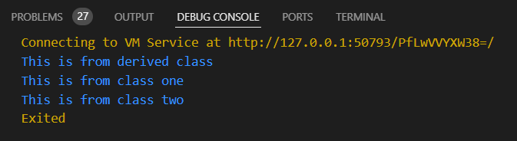

How to submit your workshop
Push your project back to the same git branch using command:
<command name>

Happy Coding!

